**Distributed Blockchain: Experiment in https://andersbrownworth.com/blockchain/distributed**

Insert your own data in the Distributed Blockchain Example - https://andersbrownworth.com/blockchain/distributed And mine it completely end to end all the levels and make a note of your mining time, change the data density to check if it takes more time to mine if the data is more. And document your learnings from the experiment o

**User Data with Low density**

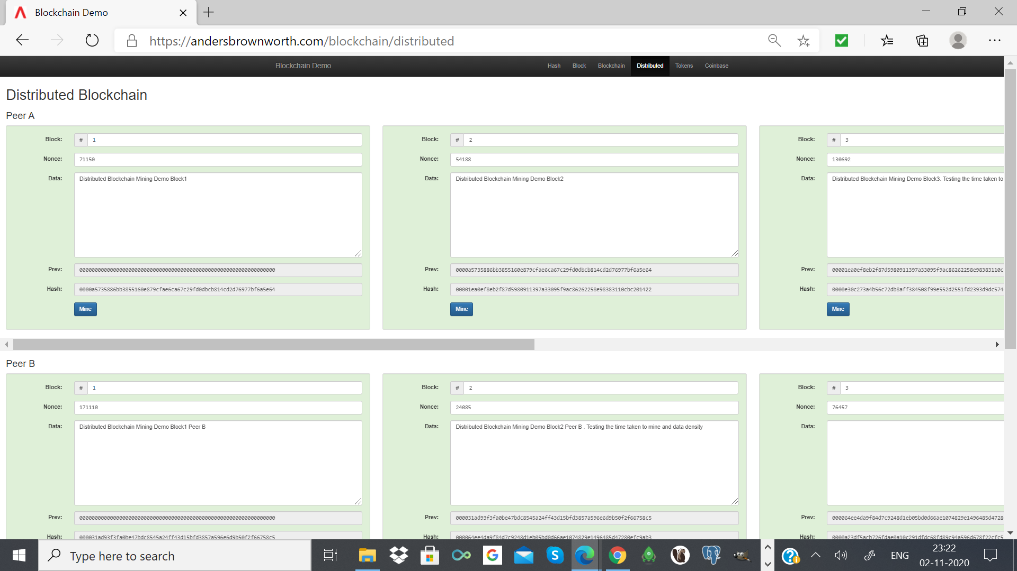

**User Data with High Density**

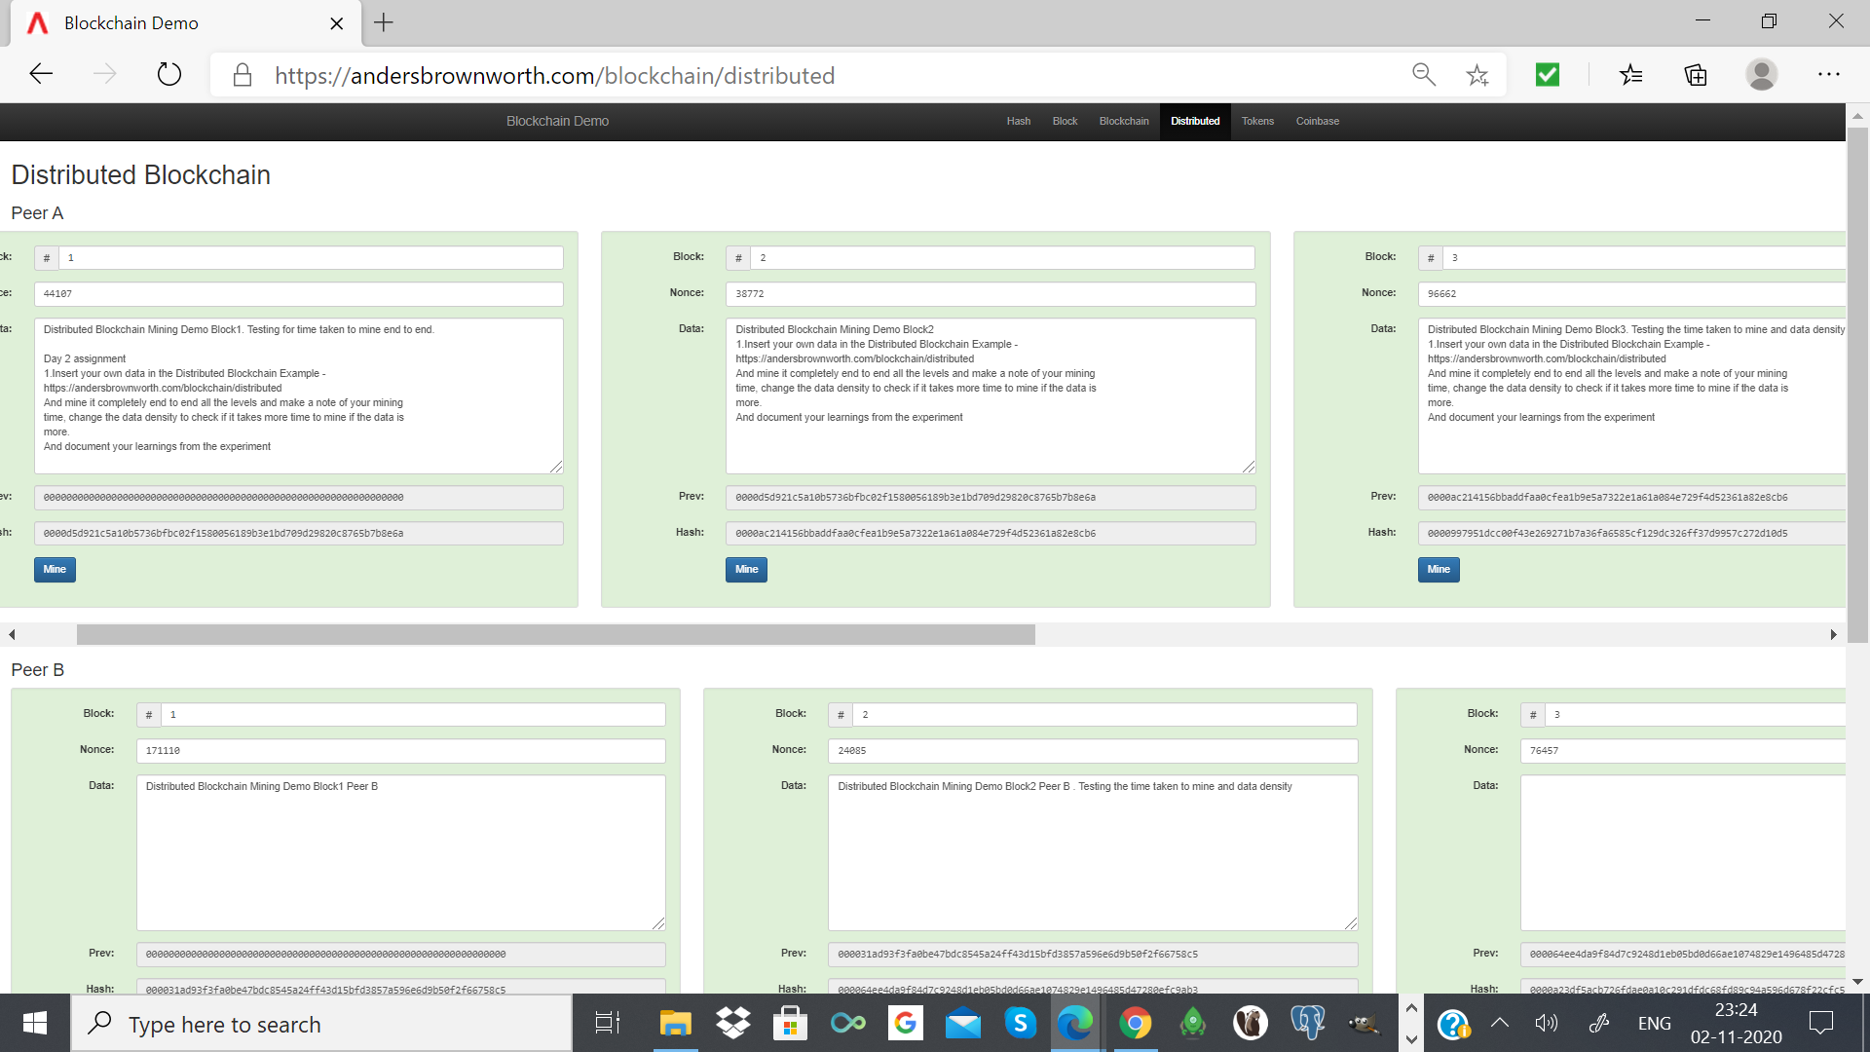

Observation: The experiment was to mine end to end with different user entered data density and compare the timings. After experimenting with various user entered data with different data density, it is noted that it takes more time to mine data with high density. The time increases with increase in data density.